European  curriculum vitae  format   |  |  | 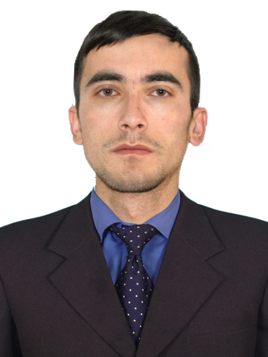
Personal information
Name |  | Berdiyev Javokhir ---------
Home Address |  | Samarkand region Ishtikhan, Azamat. home 118
Telephone |  | +99899 312-71-35
E-mail |  | javohir3324497@gmail.com
Nationality |  | Uzbekistan
Date of birth |  | 11.07.1997
Passport |  | AA9383810, Ishtikhan Samarkand region, Uzbekistan
Sphere of scientific interests |  | Web development
Work experience
• Dates (January 2020 until now)
• Name and address of employer |  | Samarkand branch of Tashkent university of information technologies named after Muhammad al –Khwarizmi, Samarkand 100202 Uzbekistan
• Type of business or sector |  | Information technology center
• Occupation or position held |  | Information Systems Implementation Unit, Software Engineer
• Main activities and responsibilities
Education and training
• Dates (20__-20__)
• Name and type of organization providing education and training
• Principal subjects/occupational
skills covered
• Title of qualification awarded
Personal skills
and competences
Mother tongue |  | Uzbek
Other languages |  | English
• Reading skills |  | Good
• Writing skills |  | Good
• Verbal skills |  | excellent
Social skills  and competences |  | Excellent ability of communication and ability to attract attention
Organisational skills  and competences |  | Good capacity to coordinate and implement complicated projects proved by numerous responsibilities held
Technical skills  and competences  With computers, specific kinds of equipment, machinery, etc. |  | Excellent ability in navigate through the Internet  Excellent knowledge of web design and web design technologies Adobe XD, Photoshop, HTML5, CSS3.  Good knowledge in programming languages: C/C++, JavaScript/Typescript.
Artistic skills |  | -
Marital status |  | Unmarried

